Signing onto ClickView Online
Open a web browser

In the address bar type:

clickview.gilmorecollege.wa.edu.au
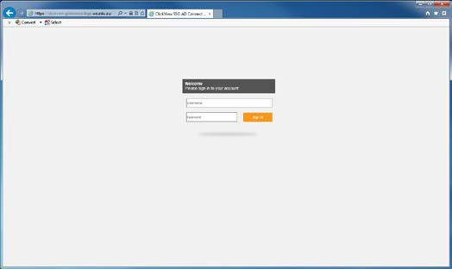

Students login using their Connect username and password.
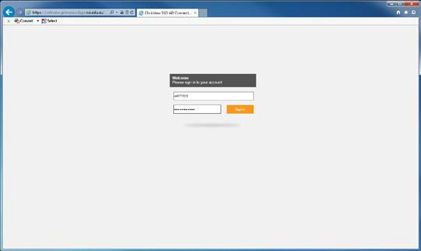

Now you are in ClickView and you can view anything in ClickView or specific videos that your teacher has linked for you in your school assignments.
